MEMORANDUM

TO: Cape Elizabeth Town Council
FROM: Maureen O'Meara, Town Planner
DATE: September 2, 2016
SUBJECT: Request authorization to apply for RTP grant, Pollack Brook Bridge
replacement

Introduction

The Conservation Committee, as part of its priority setting process for greenbelt trail improvements, has conducted a feasibility study to replace the Pollack Brook pedestrian bridge, located west of Spurwink Ave. At the August 17, 2016 meeting, the committee recommended by a vote of 5-0 that the town submit a grant application to install a new bridge. The grant would augment funds the Town Council has already approved in the FY2017 greenbelt trails account.

Summary of project

An existing 51' long wood bridge spanning Pollack Brook slipped its banks a few years ago. The bridge connected trails from the Town Farm (north) to Riverside Cemetery (south). Last fall, the Conservation Committee conducted a feasibility study to replace the bridge. In addition to mapping the adjacent wetlands, the study investigated and concluded that state permitting can probably be obtained to replace the bridge in its original location. The committee is now seeking funding to augment the greenbelt trails budget to purchase and install a "gangway" style bridge commonly used in waterfront areas. The Conservation Committee is recommending a total grant request of $50,000, with a cash match from the town of $13,500. The cash match would come from the FY 2017 Greenbelt Trails account. The grant application is due September 30th and authorization from the Town Council is a submission requirement for the grant.

Area Map

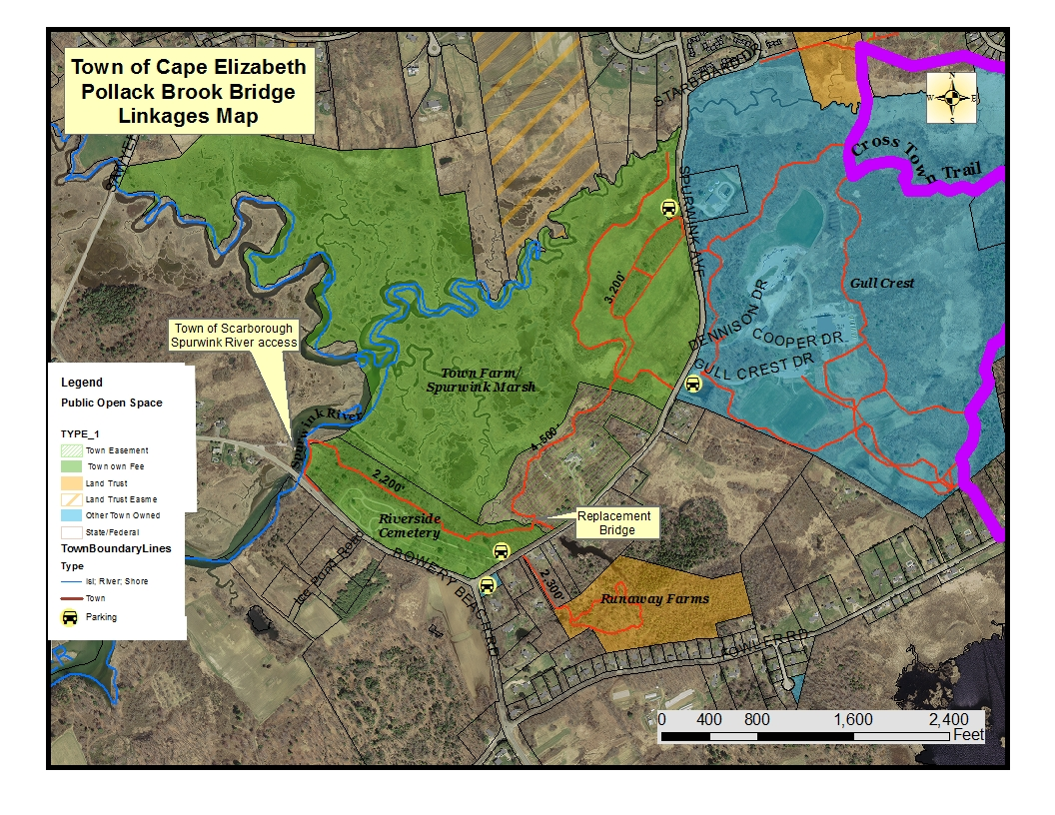

Motion for the Town Council to Consider

The Cape Elizabeth Town Council votes on September 12, 2016 in favor of applying for the Recreational Trail Development Grant from the Bureau of Parks and Lands for the construction of Pollack Brook Bridge and trail project. The vote was # - # in favor of applying for the grant.
Signed: _______________________ Debra Lane, Town Clerk

